1. The weighted travel time for hbo purpose by driveAlone is equal for middle and low income group.



$${WeightedTime}_{pikj}= \sum_{j∈center}{{Time}_{mtkj}*{Trips}_{pimkj}/\sum_{j∈center}{{Trips}_{pimkj}}}$$

Because travel time does not differ by income group, the weighted time depends on the **distribution** of trips among TAZs of centers.

2 Check trips by income groups

${Trips}_{pimkj}= {Trips}_{pikj}*{Possibility}_{pimkj}$

2.1 The ration between trips by income groups does not differ by destination TAZ.

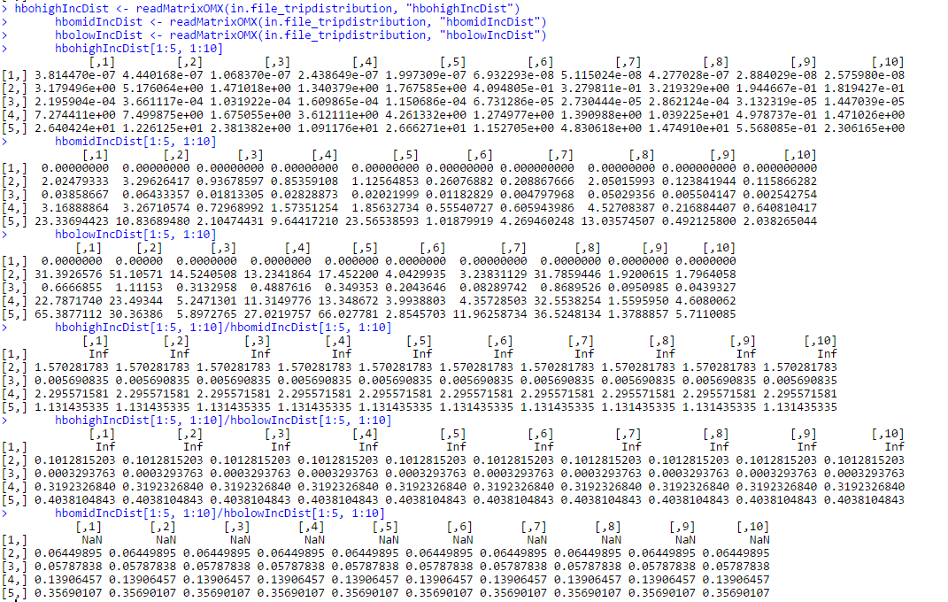

2.2 Possibility does not differ by income group

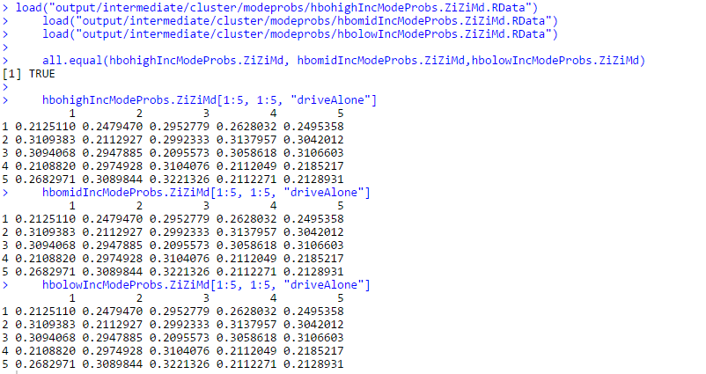

3 The utility does not differ by mode

$${Possibility}_{pimkj}={ExpUtility}_{pim}/\sum_{m}{{ExpUtility}_{pim}}$$

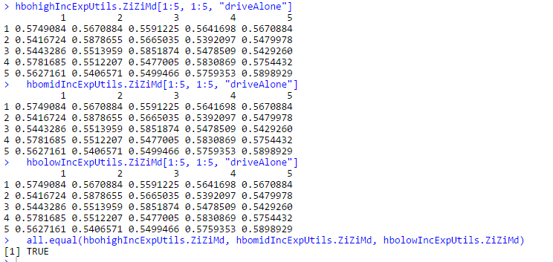

4 The formulas for calculating utility do not differ by income group

Following formulas are from original TCI, and the formulas do not differ by income group.

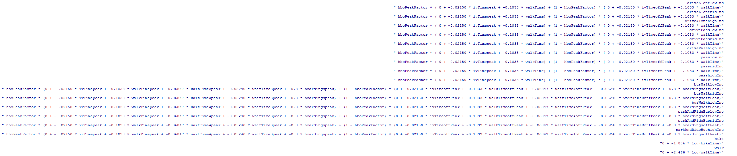

Then I check the utility calculation formula from 2013 *Trip-Based Travel Demand Model Methodology Report*, and find that the formula diff by income group. Because some variables are not available, I still need your help to simplify the formulas.